ENTITY RELATIONSHIP DOCUMENT
Retail Media Attribution
Phase 1 Logical Data Model
Derived from Retail Media Attribution - Flow, Assumptions, SQL and Final Selection
Version 1.0 | September 29, 2026
Architecture review baseline
Purpose
Translate the supplied DDLs into an auditable ER specification, identify structural gaps, and recommend the minimum production-ready Phase 1 changes.

1. Executive Summary
The supplied design has the correct core architecture: media events and transaction lines remain at their true grains, eligible matches are generated temporarily, and only one selected event-to-transaction-line relationship is persisted for each measurement run. This prevents many-to-many inflation and supports reproducible last-touch attribution.
Core principle
Raw facts remain separate. Candidate matches are temporary. The attribution bridge stores only the selected winner for each transaction line and measurement run.

Area | Entity | Role
Media | media_event_fact | One supplied impression or click; media KPI and attribution-candidate source.
Commerce | tlog_transaction_line_fact | One purchased product line; authoritative sales, units, and margin source.
Identity | shopper_identity_map | Effective-dated mapping between Activate shopper and TLOG loyalty identities.
Scope | campaign_promoted_product; halo_scope | Direct and approved halo product eligibility.
Method | attribution_rule | Versioned windows, event priority, event eligibility, and halo rule.
Attribution | attribution_link_fact | One selected event-to-line relationship per measurement run.
Processing | attribution_candidate | Temporary workspace; never an approved KPI source.

1.1 Overall assessment
- Strong: grains and the final uniqueness rule are explicit.
- Strong: direct and halo product logic is externalized from the transaction fact.
- Strong: rule version and time-window evidence are preserved.
- Gap: campaign, segment/export, product, store, and measurement-run parent entities are referenced but not defined.
- Gap: foreign keys and several business uniqueness constraints are absent.
- Gap: attribution_type mixes touch type and product scope.
- Gap: event-level ad spend is unsafe when cost is provided only at aggregate grain.

2. Logical Entity Relationship Diagram
The grey entity is temporary. All other boxes represent persistent structures in the supplied DDL. Missing parent/supporting entities are listed in Section 7.
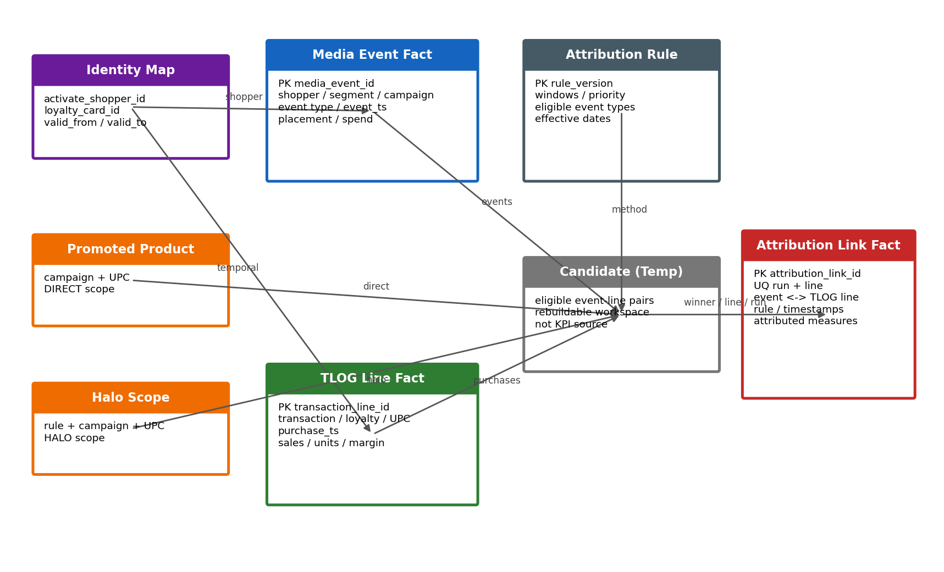
Figure 1. Phase 1 logical ERD derived from the supplied DDL.
Cardinality
A media event may win for multiple purchased lines. A transaction line may be remeasured across multiple runs, but the unique constraint permits only one winning link for that line within a run.

3. Entity Catalogue
Entity | Type | Grain | Key | Purpose
media_event_fact | Fact | One real supplied impression or click | media_event_id | Event counts and event-level candidacy.
tlog_transaction_line_fact | Fact | One product line within a transaction | transaction_line_id | Authoritative commerce measures.
shopper_identity_map | Temporal bridge | One identity relationship for a validity interval | Missing; add surrogate or composite UQ | Connects media shopper ID to loyalty card ID.
campaign_promoted_product | Scope bridge | One campaign-to-promoted-UPC relationship | Add UQ(campaign, UPC) | Determines DIRECT scope.
halo_scope | Scope bridge | One rule/campaign-to-related-UPC relationship | Add UQ(rule, campaign, UPC) | Determines approved HALO scope.
attribution_rule | Configuration | One effective-dated methodology version | Add PK(rule_version) | Controls windows, event eligibility, priority, and halo rule.
attribution_link_fact | Bridge fact | One selected event-to-line relationship per run | PK(link_id); UQ(run,line) | Approved attributed-commerce source.
attribution_candidate | Temporary | One eligible event-to-line candidate | Not persisted | Ranking workspace only; losing candidates are discarded.

3.1 Source-of-truth boundaries
- All valid media events remain countable, regardless of whether they win attribution.
- TLOG remains the primary commerce source.
- The bridge, not the candidate workspace, is the source for attributed sales, units, orders, and margin.
- Aggregate campaign totals must remain at their supplied grain and must not be exploded into event rows.
- Incrementality is not derived from this last-touch model.

4. Relationship Specification
Relationship | Cardinality | Join / rule | Integrity expectation
identity map -> TLOG line | 1:M over valid interval | loyalty_card_id plus purchase timestamp | A purchase must resolve to no more than one active map row.
identity map -> media event | 1:M logical | activate_shopper_id | Event must use an approved shopper identity.
media event -> candidate | 1:M | media_event_id | One event can be eligible for multiple purchase lines.
TLOG line -> candidate | 1:M | transaction_line_id | One line can have multiple eligible prior events.
promoted product -> candidate | 1:M | campaign + purchased UPC | Presence classifies DIRECT.
halo scope -> candidate | 1:M | rule + campaign + purchased UPC | Presence classifies approved HALO.
attribution rule -> candidate | 1:M | rule_version | Supplies windows, eligibility, and priority.
event -> attribution link | 1:M | media_event_id | One event can win multiple lines.
TLOG line -> attribution link | 1:M across runs | transaction_line_id | UQ(run,line) allows one winner in each run.
measurement run -> link | 1:M proposed | measurement_run_id | Missing parent should hold run status and lineage.

4.1 Direct and halo precedence
The SQL evaluates DIRECT before HALO. Retain that precedence, and add a test that rejects or deterministically ignores halo scope rows that overlap a promoted product for the same campaign and rule.

4.2 Temporal identity integrity
Reject overlapping identity-map intervals that allow one purchase to map to multiple Activate shopper IDs. Treat a null valid_to as open-ended.

5. Keys and Constraints
Entity | Current | Recommended production constraint
media_event_fact | PK media_event_id | Add event-type checks, nonnegative cost test, and source/batch natural-key uniqueness.
tlog_transaction_line_fact | PK transaction_line_id | Optionally add UQ(transaction_id, source_line_number); define return and void handling.
shopper_identity_map | None | Add surrogate PK or UQ(activate_shopper_id, loyalty_card_id, valid_from); prohibit overlaps.
campaign_promoted_product | None | Add UQ(campaign, UPC) and FKs to campaign/product.
halo_scope | None | Add UQ(rule, campaign, UPC) and controlled halo levels.
attribution_rule | None | Add PK(rule_version), valid date interval, and nonnegative windows.
attribution_link_fact | PK link; UQ run+line | Add FKs to run, event, line, rule, campaign, segment, shopper; check event precedes purchase.

Warehouse enforcement
If the warehouse treats keys as informational, the pipeline must run equivalent tests and block publication when a critical relationship or uniqueness rule fails.

6. Semantic and Normalization Corrections

6.1 Separate media touch from product scope
The current attribution_type values DIRECT, VIEW_THROUGH, and HALO combine two concepts. DIRECT/HALO describes product scope, while click-through/view-through describes the selected media touch.
Field | Recommended values | Meaning
selected_touch_type | CLICK_THROUGH; VIEW_THROUGH | Type of selected event.
product_scope_type | DIRECT; BRAND_HALO; BRAND_CATEGORY_HALO | Relationship of purchase to promoted scope.
attribution_method | LAST_TOUCH; future governed values | Method that selected the link.

6.2 Snapshot commerce measures deliberately
Keeping attributed sales, units, and margin in the bridge is appropriate for immutable result snapshots. Add currency, sales basis, return treatment, source snapshot/version, and calculation timestamp so reconciliation remains meaningful.

6.3 Preserve cost at the supplied grain
Keep ad_spend on the event only if it is genuinely supplied per event. Otherwise use a separate campaign_delivery_fact or media_cost_fact at daily/hourly/campaign-media grain. This avoids multiplying aggregate spend across event rows.

6.4 Normalize eligible event types
For platform portability, replace or supplement the ARRAY field with a child table keyed by rule_version, event_type, and optional impression_type.

7. Missing Parent and Supporting Entities
Entity | Priority | Minimum purpose/content
measurement_run | Required | Run period, rule, input snapshots, code version, status, start/end timestamps.
campaign_dim | Required | Internal and partner campaign IDs, dates, advertiser, retailer/banner, status, currency.
campaign_segment_bridge | Required if M:M | Validated campaign-to-segment/export-version relationship.
segment_export_fact | Required | Frozen exported audience membership, export time, destination, status, and batch.
product_dim | Required | Catalog internal ID, UPC, partner product code, brand, category, effective dates.
campaign_delivery_fact | Required for aggregates | Impressions, clicks, spend, reach at true supplied grain.
source_ingestion_batch | Required | File/object lineage, checksum, row counts, timestamps, status.
shopper_dim | Recommended | Canonical shopper identity and governance metadata.
store_dim | Recommended | Store, banner, market, timezone, and effective dates.
kpi_result_fact | Recommended | Published KPI value, numerator, denominator, grain, method, status, and lineage.

Important
These are recommended because the supplied flow references or operationally depends on them. They are not fully defined by the provided DDL.

8. KPI and Reporting Implications
KPI family | Authoritative source | Rule
Impressions / clicks | media_event_fact or aggregate delivery fact | Count all valid deduplicated events; winner selection does not remove events.
Exposed shoppers | media_event_fact | Distinct approved shopper IDs; explicitly define qualifying event types.
Attributed orders | attribution_link_fact | Distinct transaction IDs in a measurement run.
Attributed sales / units / margin | attribution_link_fact, reconciled to TLOG | Aggregate selected links only; keep direct and halo separate.
ROAS | Attributed sales plus compatible spend fact | Use same campaign, period, currency, and scope. Do not sum ROAS.
Incrementality | Not supported here | Requires separate treatment/control methodology and result entities.

8.1 Unsafe patterns
- Joining aggregate delivery or spend to event or transaction rows.
- Using attribution_candidate for KPIs.
- Counting only winning events as delivered media.
- Summing reach, buyers, rates, averages, or ROAS across incompatible grains.
- Blending partner-reported and Activate-calculated attribution without labels.
- Presenting last-touch attribution as causal lift.

9. Data Quality and Publication Gates
Gate | Test | Expected result
Uniqueness | No duplicate media_event_id | Zero duplicates after approved deduplication.
One credit | Group links by run + line | No count greater than one.
Time order | event timestamp < purchase timestamp | No invalid links.
Window | Elapsed time within configured window | Every link passes active rule.
Identity | One active map row per purchase | No ambiguous approved links.
Product scope | Each link is direct or approved halo | No unrelated product links.
TLOG reconciliation | Bridge snapshots equal approved TLOG values | Within currency tolerance.
Campaign recognition | IDs resolve to campaign master | Meets approved completeness threshold.
Reproducibility | Same inputs and rule produce same winners | Zero differences.
Spend compatibility | Sales and spend scopes align | Block ROAS publication otherwise.

10. Recommended Phase 1 Target

10.1 Retain
- True-grain media event and TLOG line facts.
- Temporary candidate workspace.
- Persisted selected attribution bridge.
- Versioned attribution methodology.
- Separate direct and governed halo scope.

10.2 Add before production
- Measurement-run parent and immutable input lineage.
- Campaign master and validated campaign-to-segment/export relationship.
- Frozen audience/export membership evidence.
- Product dimension with partner code, UPC, brand, and category mapping.
- Ingestion-batch lineage.
- Explicit constraints or equivalent pipeline tests.
- Separate touch type, product scope, and attribution method.
- Aggregate delivery/cost fact where metrics are not event-level.

10.3 Defer unless independently approved
- Incrementality, causal lift, and iROAS.
- Fractional or multi-touch attribution.
- Combined event-level and aggregate-only reach/buyers when deduplication is impossible.
- Unapproved category or cross-category halo.

11. Open Decisions
Decision | Impact | Suggested owner
Returned shopper ID and mapping | Identity match and join key. | Integration + Data Governance
Campaign-to-segment cardinality | Need for bridge and export version. | Product + Partner
Event/impression taxonomy | Eligibility and reporting. | Product + Partner
Touch priority | Winning event and results. | Measurement Governance
Attribution windows | Eligible purchases and maturity. | Measurement Governance
Phase 1 halo scope | Qualifying non-promoted purchases. | Product + Methodology
Event-level data guarantee | Whether shopper-level last touch is possible. | Partner Integration
Authoritative spend source/grain | Valid ROAS denominator. | Finance + Integration
Gross/net sales and returns | Attributed sales reconciliation. | Product + Finance
Warehouse dialect | Arrays, timestamps, UUIDs, constraints. | Data Engineering

Appendix A. Source Traceability
Source content | Use in this document
Core design principle | Fact separation and bridge persistence.
Logical ER section | Entities and intended cardinality.
DDL 4.1-4.4 | Columns, grains, declared keys, constraints.
SQL 4.5-4.8 | Join paths, eligibility, ranking, and KPI sources.
Worked example | One event can win multiple lines; one winner per line/run.
Validation and open decisions | Quality gates and unresolved methodology/integration choices.

Primary source: Retail Media Attribution - Flow, Assumptions, SQL and Final Selection, September 27, 2026.

